Lab Objective

Learn how to Perform File, Folder, and Shortcut Deployment

**Lab Procedures**

**1.** On RWDC01, using the Group Policy Management Editor for GPO5, navigate to and click User Configuration\Preferences\Windows Settings\Files.

**2.** Right-click the Files node, click New, and select File. The New File Properties dialog box opens.

**3.** In the Source file(s) text box, and type **\\Server01\Data\Hello.bat**.

**4.** In the Destination File, click c:\hello.bat.

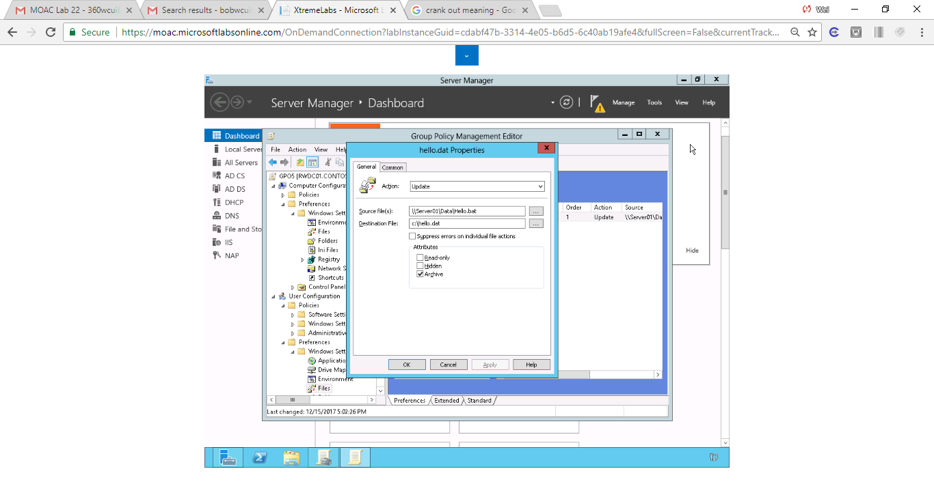

Figure 1 Set up File properties with source file \\Server01\Data\Hello.bat and Destination file of c:\hello.bat

**5.** Take a screen shot of the New File Properties dialog box by pressing Alt+Prt Scr and then paste it into your Lab22_worksheet file in the page provided by pressing Ctrl+V.

**6.** Click OK to close the New File Properties dialog box.

**7.** Navigate to and click Computer Configuration\Preferences\Windows Settings\Folders.

**8.** Right-click the Folders node, click New, and select Folder. The New Folder Properties dialog box opens.

**9.** For the Action, select Create. In the Path text box, type **C:\Batch**.

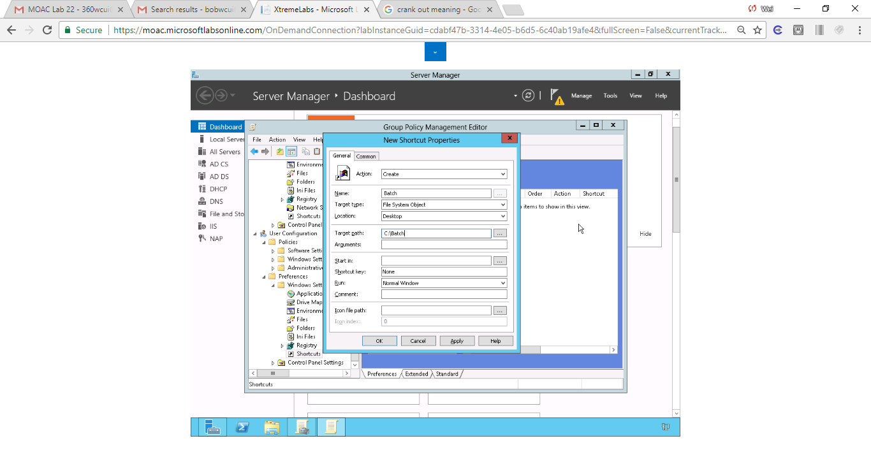

Figure 2. Set up new shortcut with target path of c:\bath

**10.** Click OK to close the New Folder Properties dialog box.

**11.** Navigate to and click User Configuration\Preferences\Windows Settings\Shortcuts.

**12.** Right-click the Shortcuts node, click New, and select Shortcut. The New Shortcut Properties dialog box opens.

**13.** For the Action, select Create.

**14.** In the Name text box, type **Batch**.

**15.** Using the Location pull-down menu, select Desktop.

**16.** In the Target Path text box, type **C:\Batch**.

**17.** Click OK to close the New Shortcut Properties. The new preference item appears in the Shortcuts pane.

**18.** Close the Group Policy Management Editor.

**Lab Summary**

During this exercise, I created a folder, copied a file to the folder, and created a shortcut to the folder using GPO Preferences. The mindset question asks when performing a file deployment, what is the difference between Create and Update? Create creates a new preference settings for the user and update updates an exisitng one. I also noticed Delete action can’t delete built-in preferences but can delete user-created ones.